

Semester Two Examination, 2017

Question/Answer booklet

MATHEMATICS

SOLUTIONS
METHODS
UNITS 3 AND 4

Section Two:

Calculator-assumed

Student Number: In figures

In words

Your name

Time allowed for this section
Reading time before commencing work: ten minutes
Working time: one hundred minutes

Materials required/recommended for this section
To be provided by the supervisor
This Question/Answer booklet
Formula sheet (retained from Section One)

To be provided by the candidate
Standard items: pens (blue/black preferred), pencils (including coloured), sharpener, correction fluid/tape, eraser, ruler, highlighters

Special items: drawing instruments, templates, notes on two unfolded sheets of A4 paper, and up to three calculators approved for use in this examination

Important note to candidates
No other items may be taken into the examination room. It is your responsibility to ensure that you do not have any unauthorised material. If you have any unauthorised material with you, hand it to the supervisor before reading any further.

Structure of this paper

Section | Number of questions available | Number of questions to be answered | Working  time (minutes) | Marks available | Percentage of examination
Section One:  Calculator-free | 8 | 8 | 50 | 52 | 35
Section Two:  Calculator-assumed | 13 | 13 | 100 | 97 | 65
 |  |  |  | Total | 100

Instructions to candidates

1. The rules for the conduct of examinations are detailed in the school handbook. Sitting this examination implies that you agree to abide by these rules.

2. Write your answers in this Question/Answer booklet.

3. You must be careful to confine your response to the specific question asked and to follow any instructions that are specified to a particular question.

4. Additional working space pages at the end of this Question/Answer booklet are for planning or continuing an answer. If you use these pages, indicate at the original answer, the page number it is planned/continued on and write the question number being planned/continued on the additional working space page.

5. Show all your working clearly. Your working should be in sufficient detail to allow your answers to be checked readily and for marks to be awarded for reasoning. Incorrect answers given without supporting reasoning cannot be allocated any marks. For any question or part question worth more than two marks, valid working or justification is required to receive full marks. If you repeat any question, ensure that you cancel the answer you do not wish to have marked.

6. It is recommended that you do not use pencil, except in diagrams.

7. The Formula sheet is not to be handed in with your Question/Answer booklet.

Section Two: Calculator-assumed 65% (97 Marks)
This section has thirteen (13) questions. Answer all questions. Write your answers in the spaces provided.

Working time: 100 minutes.

Question 9 (8 marks)
The graph of $y=f(x)$ is shown below for $0≤x≤2$, where $f\left(x\right)=1+2xe^{1-x}$.

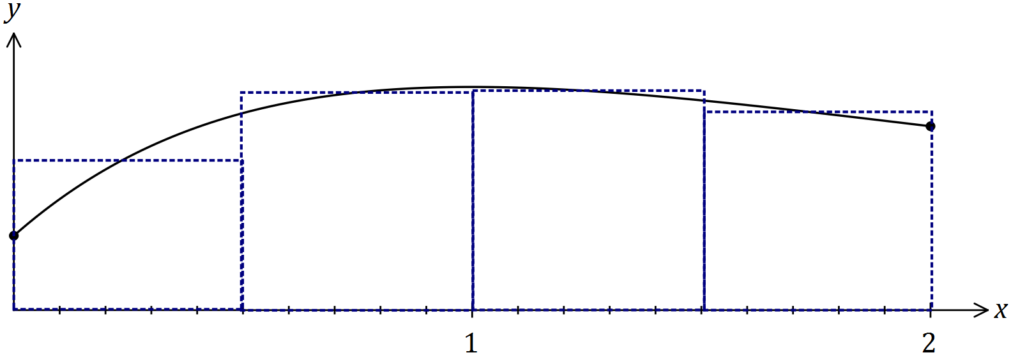
Solution (b)(i)
See graph
Specific behaviours
correct heights
correct centres

(a) Show that $f(x)$ has a stationary point at $(1, 3)$. (3 marks)
Solution
$$f^{'}\left(x\right)=2\left(1-x\right)e^{1-x}$$
$$f^{'}\left(x\right)=0 \text{when} x=1$$
$$f\left(1\right)=1+2e^{0}=3$$
$$\text{Hence stationary point at} (1, 3)$$

Specific behaviours
shows derivative
shows $f^{'}\left(x\right)$ has a factor of $(1-x)$
indicates $f(1)$

(b) An estimate for the area bounded by the curve, the $x$-axis, the $y$-axis and the line $x=2$ is required. A suitable estimate can be calculated from the sum of the areas of four centred rectangles with heights $f\left(0.25\right), f\left(0.75\right), f\left(1.25\right)$ and $f(1.75)$, each with a width of $0.5$ units.

(i) Clearly show these four rectangles on the graph above. (2 marks)

(ii) Use the rectangles to estimate the area, giving your answer correct to 2 decimal places. (3 marks)
Solution
$$A=0.5\left(2.0585+2.9260+2.9470+2.6533\right) \\ A=5.2924≈5.29 \text{(2dp)}$$

Specific behaviours
indicates correct heights
multiplies by width
correct area

Question 10 (7 marks)
The capacity, $X$ mL, of glass bottles made in a factory can be modelled by a normal distribution with mean $μ$ and standard deviation $3.4$ mL.

(a) If $μ=784$, determine

(i) $P(X≥780)$. (1 mark)
Solution
$$P=0.8803$$

Specific behaviours
states probability

(ii) $P\left(X<786 \right| X>780)$. (2 marks)
Solution
$$P\left(780<X<786\right)=0.6021$$

$$P=\frac{0.6021}{0.8803}=0.6840$$

Specific behaviours
calculates numerator
states probability

(iii) the value of $x$, if $P\left(X≤x\right)=\frac{1}{3}$. (1 mark)
Solution
$$x=782.5$$

Specific behaviours
states value

(b) Given that $P\left(X>k\right)=0.937$,

(i) determine the value of $μ$ in terms of $k$. (2 marks)
Solution
$$\frac{k-μ}{3.4}=-1.53 \\ μ=k+5.202$$

Specific behaviours
equation using correct $z$-score
expression for $μ$, correct to 1 dp

(ii) determine $μ$ if $k=503$. (1 mark)
Solution
$μ=508.2$ mL

Specific behaviours
states value

Question 11 (8 marks)
From a random survey of 355 users of a free SMS service, it was found that 212 would stop using it if they had to pay.

(a) Based on this survey, calculate the percentage of users who would stop using the service. (1 mark)
Solution
$$\frac{212}{355}×100=59.7\%$$

Specific behaviours
calculates percentage

(b) Calculate the approximate margin of error for a 95% confidence interval estimate of the proportion of users who would stop using the service. (3 marks)
Solution
$$z_{0.95}=1.96 \\ SE=\sqrt{\frac{0.597(1-0.597)}{355}}=0.0260 \\ E=1.96×0.026=0.051$$

Specific behaviours
uses correct $z$-score
calculates standard error
calculates margin of error

(c) Determine a 95% confidence interval for the proportion of users who would stop using the service. (2 marks)
Solution
$$0.597±0.051=(0.546, 0.648)$$

Specific behaviours
writes interval
rounds to 2, 3 or 4 decimal places

(d) If 30 identical surveys were carried out and a 95% confidence interval for the proportion was calculated from each survey, determine the probability that at least 29 of the intervals will contain the true value of the proportion. (2 marks)
Solution
$$Y\sim B\left(30, 0.95\right)$$
$$P\left(Y≥29\right)=0.5535$$

Specific behaviours
states parameters of binomial distribution
calculates probability

Question 12 (7 marks)
The length, $T$ minutes, of phone calls to a help line is a continuous random variable with probability density function given by

$$f\left(t\right)=0.3e^{-0.3t}, 0≤t<∞.$$

(a) Determine the probability that a randomly chosen call lasts less than $6$ minutes. (2 marks)
Solution
$$P\left(T<6\right)=\int_{0}^{6}{f\left(t\right)}dt \\ =0.8347$$

Specific behaviours
writes integral
evaluates

(b) An operator answers $20$ calls, chosen at random. If call times are independent of each other, determine the probability that at least $4$ of them will exceed $6$ minutes. (2 marks)
Solution
$$Y\sim B\left(20, 1-0.8347\right)$$

$$P\left(Y≥4\right)=0.4268$$

Specific behaviours
indicates binomial distribution with parameters
calculates probability

(c) An operator has been on a call for exactly $7$ minutes. Determine the probability that the call will end within the next minute. (3 marks)
Solution
$$P\left(T>7\right)=\int_{7}^{∞}{f(t)}dt=0.1225 \\ P\left(7<T<8\right)=\int_{7}^{8}{f(t)}dt=0.0317 \\ P\left(T<476 \right| T>440)=\frac{0.0317}{0.1225}=0.2592$$

Specific behaviours
$P\left(T>7\right)$
$P\left(7<T<8\right)$
probability

Question 13 (9 marks)
A fair die has one face numbered 1, three faces numbered 2 and two faces numbered 3.

(a) Determine the probability that the second even number occurs on the fourth throw of the dice. (3 marks)
Solution
$$P\left(1 \text{even in 3 throws}\right)=\frac{1}{2}×{\left(\frac{1}{2}\right)}^{2}×3=\frac{3}{8}$$
$$P=\frac{3}{8}×\frac{1}{2}=\frac{3}{16} (=0.1875)$$

Specific behaviours
uses $P\left(\text{even}\right)=\frac{1}{2}$
uses binomial expansion for 1 even in 3 throws
calculates probability

(b) The die is thrown twice and $X$ is the sum of the two scores.

(i) Complete the table below to show the probability distribution of $X$. (2 marks)

$$x$$ | $$2$$ | $$3$$ | $$4$$ | $$5$$ | $$6$$
$$P(X=x)$$ | $$\frac{1}{36}$$ | $$\frac{1}{6}$$ | $$\frac{13}{36}$$ | $$\frac{1}{3}$$ | $$\frac{1}{9}$$
Solution
$$P\left(X=2\right)=\frac{1}{6}×\frac{1}{6}=\frac{1}{36}, P\left(X=6\right)=\frac{1}{3}×\frac{1}{3}=\frac{1}{9}$$

Specific behaviours
$P\left(X=2\right)$
$P(X=6)$

(ii) Determine $P\left(X=5 \right| X≥5)$. (2 marks)
Solution
$$P=\frac{1}{3}÷\left(\frac{1}{3}+\frac{1}{9}\right)=\frac{3}{4}$$

Specific behaviours36
$P\left(X≥5\right)$
probability

(iii) Calculate $E{(X)}$. (2 marks)
Solution
$$E{(X)}=\frac{1}{18}+\frac{9}{18}+\frac{26}{18}+\frac{30}{18}+\frac{12}{18}=\frac{78}{18}=\frac{13}{3}$$

Specific behaviours
uses sum of $x×P\left(X=x\right)$
simplifies

Question 14 (8 marks)
150 black and 850 white spherical beads, identical except for their colour, are placed in a container and thoroughly mixed.

In experiment $A$, a bead is randomly selected, its colour noted and then replaced until a total of 40 beads have been selected.

(a) The random variable $X$ is the number of black beads selected in experiment $A$.
Determine $P(X>9)$. (2 marks)
Solution
$$X\sim B\left(40, 0.15\right)$$
$$P\left(X≥10\right)=0.0672$$

Specific behaviours
indicates binomial RV, with parameters
states P

(b) Experiment $A$ is repeated 20 times. Determine the probability that at least one black bead is selected in each of these experiments. (2 marks)
Solution
$$P\left(X≥1\right)=0.9985$$
$${0.9985}^{20}=0.9704$$

Specific behaviours
calculates at least one black
states probability

In experiment $B$, a bead is randomly selected, its colour noted and then replaced until a total of 25 beads have been selected.

Experiments $A$ and $B$ are repeated a large number of times, with the proportions of black beads in each experiment, ${\hat{p}}_{A}$ and ${\hat{p}}_{B}$ respectively, recorded.

(c) The distribution of which proportion, ${\hat{p}}_{A}$ or ${\hat{p}}_{B}$, is most likely to approximate normality? Explain your answer and state the mean and standard deviation of the normal distribution for the proportion you have chosen. (4 marks)
Solution
${\hat{p}}_{A}$ most likely, as it is based on a larger sample size (40 rather than 25).
Parameters:
Mean: $0.15$
Variance: $\frac{0.15(1-0.15)}{40}=0.00319$, $s_{x}=0.056$

Specific behaviours
chooses ${\hat{p}}_{A}$
explains ${\hat{p}}_{A}$ is based on larger sample size
states mean
states standard deviation

Question 15 (8 marks)
A researcher wants to estimate the proportion of Western Australian teachers who are aged under 30. The researcher plans to collect sample data by visiting schools and asking teachers.

(a) Discuss two different sources of bias that may occur when the researcher collects their sample data and suggest a procedure to avoid bias. (4 marks)
Solution
Undercoverage (including volunteer or convenience sampling) - the researcher should ensure that all teachers have an equal chance of being selected, rather than favouring gender, type of school, etc
Nonresponse - some teachers may choose not to answer the question
Etc, etc

To avoid bias use
Simple random sampling - number all teachers and select numbers at random
Systematic sampling - number all teachers and select every $k$^{th} teacher
Etc, etc

Specific behaviours
discusses one source of bias
discusses second source of bias
suggests a suitable type of sampling
explains sampling procedure

(b) Determine, to the nearest 10, the sample size the researcher should use to ensure that the margin of error of a 95% confidence interval is no more than 3%. (3 marks)
Solution
$$n=\frac{{1.96}^{2}\left(0.5\right)\left(1-0.5\right)}{{0.03}^{2}} \\ n=1067$$
$$\text{Sample size of }1070 \text{teachers}$$

Specific behaviours
assumes $\hat{p}=0.5$
shows sample size equation
calculates $n$

(c) Comment on how your answer to (b) would change if the researcher had a reliable estimate that the population proportion was close to 12%. (1 mark)
Solution
Size of sample would decrease (to close to 450)

Specific behaviours
states decrease

Question 16 (7 marks)
The curve $y=5π-x+\sin{x}$ is shown below passing through $P(3π, 2π)$.

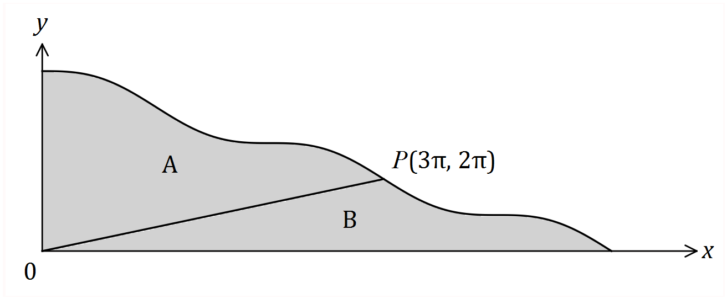

A straight line joins the origin to $P$, dividing the shaded area into two regions, $A$ and $B$.

(a) Show that when $x=5π$, $y=0$. (1 mark)
Solution
$$y=5π-5π+\sin{5π}=0$$

Specific behaviours
substitutes

(b) Determine the value of $\int_{0}^{3π}{\overset{ }{\underset{ }{\left(5π-x+\sin{x}\right)}}}dx$. (2 marks)
Solution
$$I=\frac{21π^{2}}{2}+2 (≈105.6)$$

Specific behaviours
evaluates integral
states exact value

(c) Determine the ratio of the area of region $A$ to the area of region $B$ in the form $1:k$.
(4 marks)
Solution
$$\int_{0}^{3π}{\left(\frac{2x}{3}\right)}dx=3π^{2}$$

$$\int_{3π}^{5π}{\left(5π-x+\sin{x}\right)}dx=2π^{2}$$

$$A=\frac{21π^{2}}{2}+2-3π^{2}=\frac{15π^{2}}{2}+2$$

$$B=2π^{2}+3π^{2}=5π^{2}$$

$$\text{Ratio A:B} \text{is} 1:0.649$$

Specific behaviours
evaluates area of triangle
evaluates area A
evaluates area B
states ratio in required form

Question 17 (8 marks)
Hick's law, shown below, models the average time, $T$ seconds, for a person to make a selection when presented with $n$ equally probable choices.

$T=a+b\log_{2}{(n+1)}$, where $a$ and $b$ are positive constants.

(a) Draw the graph of $T$ vs $n$ on the axes below when $a=4$ and $b=8$. (3 marks)

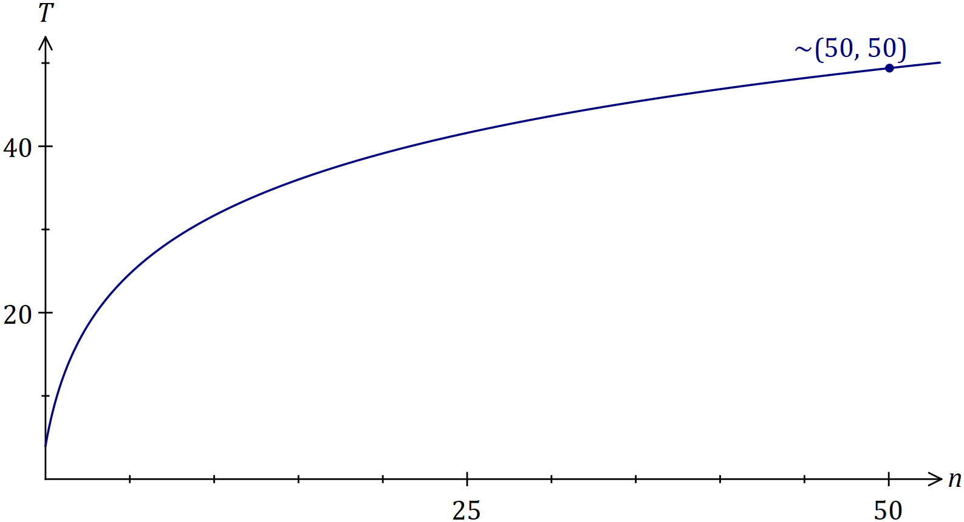
Solution
See graph
Specific behaviours
adds scale to $y$-axis
endpoints
log-shaped curve

(b) When a pizzeria had 10 choices of pizza, the average time for patrons to make a choice was 40 seconds. After doubling the number of choices, the average time to make their choice increased by 25%.

Modelling the relationship with Hick's law, predict the average time to make a choice if patrons were offered a choice of 35 pizzas. (5 marks)
Solution
$$40=a+b\log_{2}{(10+1)} \\ 40×1.25=a+b\log_{2}\left(2×10+1\right) \\ a=2.917, b=10.719 \\ T=2.917+10.719\log_{2}{(35+1)} \\ T=58.34≈58 \text{seconds}$$

Specific behaviours
writes first equation
writes second equation
solves for variables
substitutes correctly
states time, rounded to nearest second

Question 18 (7 marks)
A polynomial function $f(x)$ is such that $\int_{3}^{7}{\overset{ }{\underset{ }{3f\left(x\right)}}}dx=21 .$

(a) Show that $\int_{7}^{3}{\overset{ }{\underset{ }{f\left(x\right)}}}dx=-7$. (2 marks)
Solution
$$3\int_{7}^{3}{f\left(x\right)}dx=-21 \\ \int_{7}^{3}{f\left(x\right)}dx=-7$$

Specific behaviours
reverses limits and changes sign
factors and divides

(b) Determine the value of $\int_{3}^{4}{\overset{ }{\underset{ }{\left(f\left(x\right)+3\right)}}}dx+\int_{4}^{7}{\overset{ }{\underset{ }{\left(3+2x+f\left(x\right) \right)}}}dx$. (5 marks)
Solution
$$=\int_{3}^{4}{\left(f\left(x\right)\right)}dx+\int_{3}^{4}{\left(3\right)}dx+\int_{4}^{7}{\left(3\right)}dx+\int_{4}^{7}{\left(2x\right)}dx+\int_{4}^{7}{\left(f(x)\right)}dx \\ =\int_{3}^{7}{\left(f(x)\right)}dx+\int_{3}^{7}{\left(3\right)}dx+\int_{4}^{7}{\left(2x\right)}dx \\ =7+12+{\left[x^{2}\right]}_{4}^{7} \\ =7+12+33 \\ =52$$

Specific behaviours
uses linearity to split
uses interval addition with $f$
integrates
evaluates
correct sum

Question 19 (8 marks)
The mass, $X$ g, of wasted metal when a cast is made is a random variable with probability density function given by
$$f\left(x\right)=\left\{\begin{matrix}\frac{2x}{a^{2}} & 0≤x≤a, \\ & \\ 0 & \text{elsewhere},\end{matrix}\right.$$

where $a$ is a positive constant.

(a) Determine $E{(X)}$ in terms of $a$. (2 marks)
Solution
$$\int_{0}^{a}{\frac{2x}{a^{2}}}×x dx=\frac{2a}{3}$$

Specific behaviours
writes correct integral
evaluates integral in terms of $a$

(b) The total mass of wasted metal from a random sample of 40 casts was 960 g. Estimate the value of $a$. (2 marks)
Solution
$$\overline{x}=960÷40=24$$
$$\frac{2a}{3}=24⇒a=36$$

Specific behaviours
calculates sample mean
determines $a$

(c) If $a=12$, determine

(i) $P(X≥4)$. (1 mark)
Solution
$$\int_{4}^{12}{\frac{2x}{144}dx=\frac{8}{9}}$$

Specific behaviours
evaluates probability

(ii) $\operatorname{Var}{(X)}$. (3 marks)
Solution
$$E{(X)}=2×12÷3=8$$

$$\int_{0}^{12}{\frac{2x{\left(x-8\right)}^{2}}{144}dx=8}$$

Specific behaviours
shows value of $E{(X)}$
writes correct integral
evaluates variance

Question 20 (6 marks)
A random sample of 460 koalas from a nature reserve are captured, tagged and then set free. After a suitable interval, during which time it is assumed that the koala population does not change, another random sample of 280 koalas is caught and 14 of these are observed to be tagged.

(a) Show that a point estimate for the size of the koala population is 9 200. (1 mark)
Solution
$$\frac{460}{P}=\frac{14}{280}⇒P=9200$$

Specific behaviours
shows use of direct proportion

(b) Construct a 98% confidence interval for the proportion of koalas in the population that are tagged. (2 marks)
Solution
$$\hat{p}=\frac{14}{280}=0.05, E=0.0303, z_{0.98}=2.326$$

$$(0.0197, 0.0803)$$

Specific behaviours
calculates margin of error
states confidence interval

(c) Deduce an approximate 98% confidence interval for the number of koalas in the reserve.
(3 marks)
Solution
$$P_{L}=\frac{460}{0.0803}=5729$$
$$P_{U}=\frac{460}{0.0197}=23350$$

$$(5 700, 23 400)$$

Specific behaviours
calculates lower value
calculates upper value
rounds sensibly (eg 00's)

Question 21 (6 marks)
A popcorn container of capacity $275$ mL is made from paper and has the shape of an open inverted cone of radius $r$ and height $h$.

Determine the least area of paper required to make the container. (6 marks)

Solution
$$A=πrs=πr\sqrt{r^{2}+h^{2}}$$

$$V=\frac{1}{3}πr^{2}h⇒h=\frac{3V}{πr^{2}}$$

$$A=πr\sqrt{r^{2}+{\left(\frac{3\left(275\right)}{πr^{2}}\right)}^{2}}$$

$$\frac{dA}{dr}=\frac{2r^{6}π^{2}-680625}{r^{2}\sqrt{r^{6}π^{2}+680625}}$$

$$\frac{dA}{dr}=0 \text{when} r=5.705 \text{cm}$$

$$A_{MIN}=177.1 {\text{cm}}^{2}$$

Specific behaviours
expresses $A$ in terms of $r$ and $h$
expresses $h$ in terms of $r$
expresses $A$ in terms of $r$
differentiates $A$
finds positive zero of derivative
substitutes to find minimum area

Additional working space

Question number: _________

Additional working space

Question number: _________

Additional working space

Question number: _________

Additional working space

Question number: _________

© 2017 WA Exam Papers. Kennedy Baptist College has a non-exclusive licence to copy and communicate this document for non-commercial, educational use within the school. No other copying, communication or use is permitted without the express written permission of WA Exam Papers. SN245-105-4.

